**[Problem 1] Implementation using exponentiation arithmetic operators**

# Code to calculate the thickness when the paper is folded 43 times

THICKNESS = 0.00008

folded_thickness = THICKNESS * (2 ** 43)

print("Thickness after 43 folds: {} meters".format(folded_thickness))

**output**

Thickness after 43 folds: 703687441.77664 meters

**[Problem 2] Unit Conversion**

THICKNESS = 0.00008

folded_thickness = THICKNESS * (2 ** 43)

print("Thickness: {: .2f} kilometers".format(folded_thickness / 1000))

**output**

Thickness: 703687441.78 kilometers

**[Problem 3] Create using a for statement**

# Code to calculate the thickness when the paper is folded 43 times using a for statement

THICKNESS = 0.00008 # Initial thickness of the paper in meters

folded_thickness = THICKNESS # Start with the initial thickness

for i in range(43):

folded_thickness *= 2

print("Thickness: {: .2f} kilometers".format(folded_thickness / 1000))

**output**

Thickness: 703687.44 kilometers

**[Problem 4] Comparison of calculation time**

import time

# Number of folds to compare

FOLDS = 100000

# Method 1: Using the exponentiation operator

THICKNESS = 0.00008

start = time.time()

folded_thickness_exp = THICKNESS * (2 ** FOLDS)

elapsed_time_exp = time.time() - start

print("Exponentiation method time: {}[s]".format(elapsed_time_exp))

# Method 2: Using a for loop

folded_thickness_loop = THICKNESS

start = time.time()

for i in range(FOLDS):

folded_thickness_loop *= 2

elapsed_time_loop = time.time() - start

print("For loop method time: {}[s]".format(elapsed_time_loop))

# Compare the results

print("\nFinal Thickness with Exponentiation: {:.2e} meters".format(folded_thickness_exp))

print("Final Thickness with For Loop: {:.2e} meters".format(folded_thickness_loop))

**[Problem 5] Saving to a list**

THICKNESS = 0.00008 # Initial thickness of the paper in meters

folded_thickness = THICKNESS # Start with the initial thickness

process_values []

process_values.append(folded_thickness)

for i in range(43):

folded_thickness *= 2 # Double the thickness each time

process_values.append(folded_thickness)

print("Number of values stored:", len(process_values))

print("First value (initial thickness): {:.8f} meters".format(process_values[0]))

print("Last value (thickness after 43 folds): {:.8f} meters".format(process_values[-1]))

**output**

Number of values stored: 44

First value (initial thickness): 0.00008000 meters

Last value (thickness after 43 folds): 703687441.77664000 meters

**[Problem 6] Displaying a line graph**

import matplotlib.pyplot as plt

THICKNESS = 0.00008

folded_thickness = THICKNESS

process_values = []

process_values.append(folded_thickness)

for i in range(43):

folded_thickness *= 2

process_values.append(folded_thickness)

print("Number of values stored:", len(process_values))

plt.title("Thickness of Folded Paper")

plt.xlabel("Number of Folds")

plt.ylabel("Thickness [m]")

plt.plot(process_values)

plt.show()

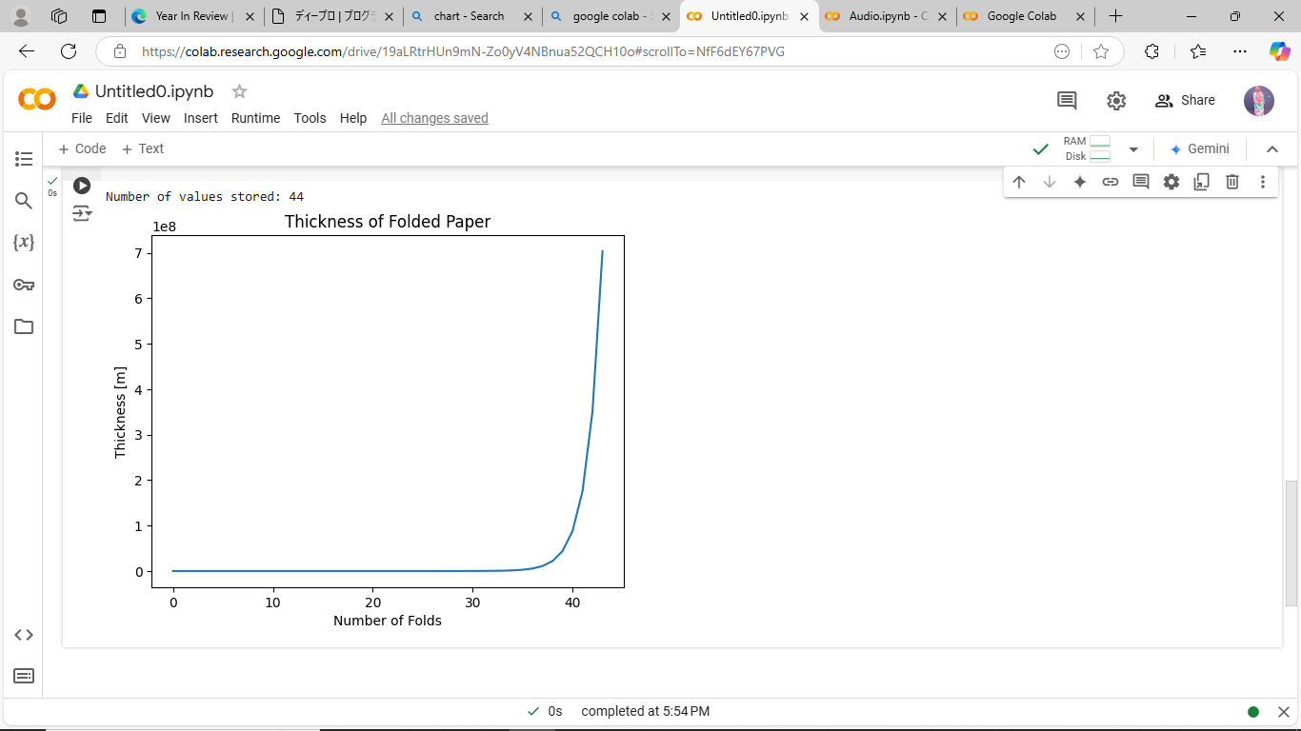

**[Problem 7] Customizing graphs**

# Green dashed line with increased line width

plt.title("Thickness of Folded Paper", fontsize=16)

plt.xlabel("Number of Folds", fontsize=12)

plt.ylabel("Thickness [m]", fontsize=12)

plt.plot(process_values, color='green', linestyle='--', linewidth=2)

plt.grid(True)

plt.show()

